# Documentation

“Western Style Ltd.” Workshop

Group 4

Group Members:

* Andrei Lucaci
* Cosmin Stan
* Cristian Moldovan
* Razvan Andrei
* Robert Ivan

Supervisors

* Istvan Knoll
* Ann Francke Riisberg
* Henrik Munk Hvarregaard

Repository path: https://github.com/Swiftrow/Group4

## Domain Model

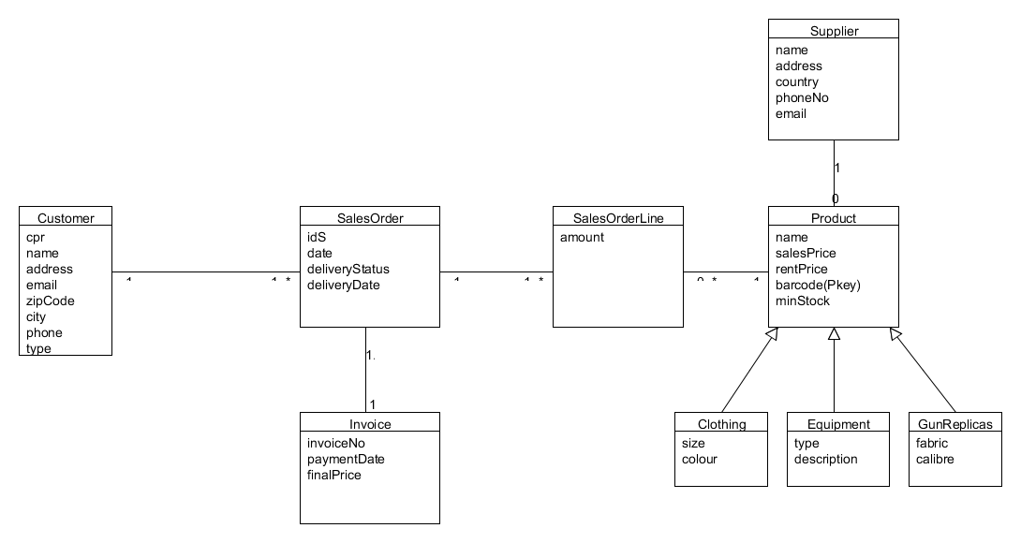

# Mock-ups, design and argumentation

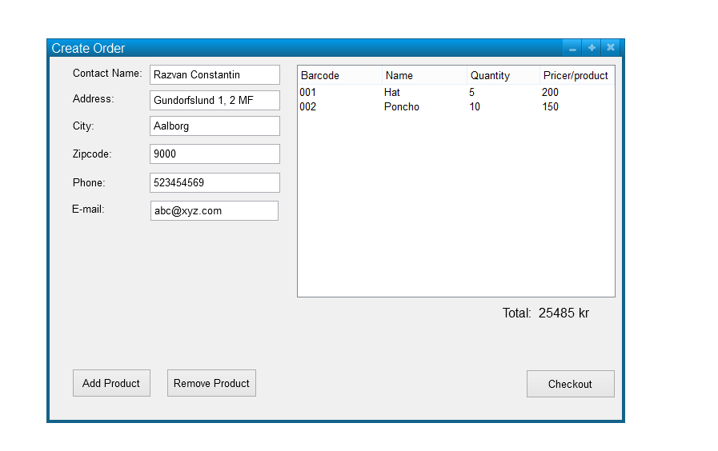

For designing the windows for our program, we used Pencil. The window has an easy-to-use layout, on the left information is inserted using text fields.

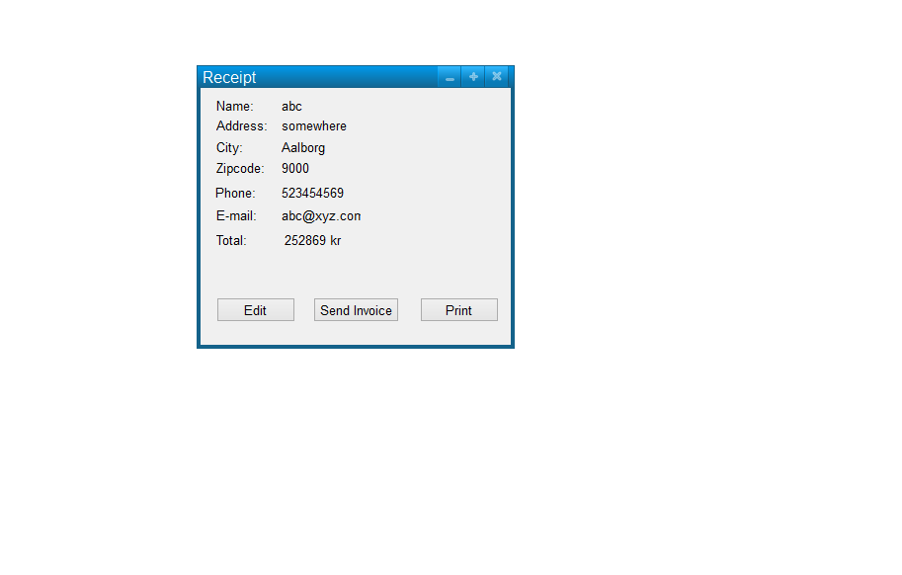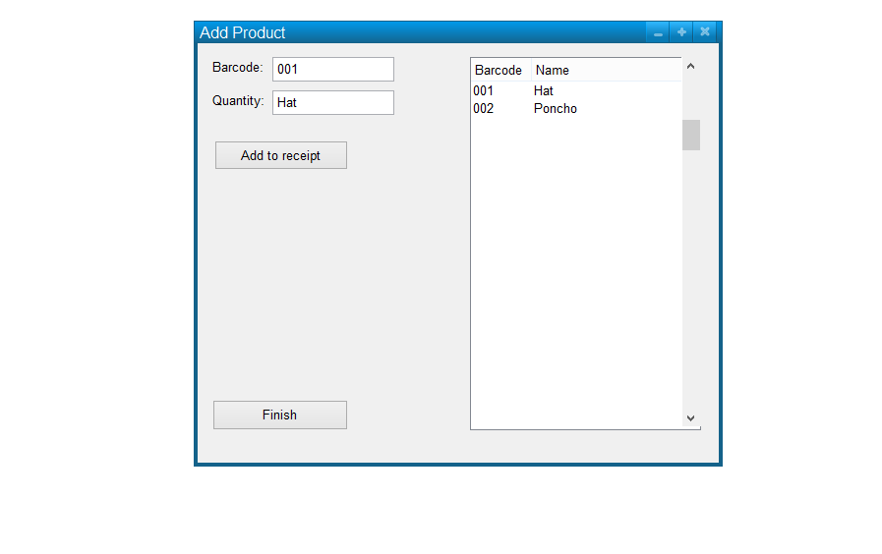

The SQL Script for the database creation

USE [dmai0914_2Sem_4]

GO

/****** Object: Table [dbo].[Address] Script Date: 20-Mar-15 4:34:21 PM ******/

SET ANSI_NULLS ON

GO

SET QUOTED_IDENTIFIER ON

GO

SET ANSI_PADDING ON

GO

CREATE TABLE [dbo].[Address](

[cpr] [numeric](10, 0) NOT NULL,

[country] [varchar](255) NOT NULL,

[city] [varchar](255) NOT NULL,

[zipcode] [varchar](255) NOT NULL

) ON [PRIMARY]

GO

SET ANSI_PADDING OFF

GO

/****** Object: Table [dbo].[Clothing] Script Date: 20-Mar-15 4:34:21 PM ******/

SET ANSI_NULLS ON

GO

SET QUOTED_IDENTIFIER ON

GO

SET ANSI_PADDING ON

GO

CREATE TABLE [dbo].[Clothing](

[barcodeC] [numeric](10, 0) NOT NULL,

[colour] [varchar](255) NOT NULL,

[size] [varchar](255) NOT NULL

) ON [PRIMARY]

GO

SET ANSI_PADDING OFF

GO

/****** Object: Table [dbo].[Customer] Script Date: 20-Mar-15 4:34:21 PM ******/

SET ANSI_NULLS ON

GO

SET QUOTED_IDENTIFIER ON

GO

SET ANSI_PADDING ON

GO

CREATE TABLE [dbo].[Customer](

[cpr] [numeric](10, 0) NOT NULL,

[name] [varchar](255) NOT NULL,

[phone] [varchar](255) NOT NULL,

[email] [varchar](255) NOT NULL,

[street] [varchar](255) NOT NULL,

[customerType] [varchar](255) NOT NULL,

PRIMARY KEY CLUSTERED

(

[cpr] ASC

)WITH (PAD_INDEX = OFF, STATISTICS_NORECOMPUTE = OFF, IGNORE_DUP_KEY = OFF, ALLOW_ROW_LOCKS = ON, ALLOW_PAGE_LOCKS = ON) ON [PRIMARY]

) ON [PRIMARY]

GO

SET ANSI_PADDING OFF

GO

/****** Object: Table [dbo].[Equipement] Script Date: 20-Mar-15 4:34:21 PM ******/

SET ANSI_NULLS ON

GO

SET QUOTED_IDENTIFIER ON

GO

SET ANSI_PADDING ON

GO

CREATE TABLE [dbo].[Equipement](

[barcodeE] [numeric](10, 0) NOT NULL,

[eqType] [varchar](255) NOT NULL,

[eqDescription] [varchar](255) NOT NULL

) ON [PRIMARY]

GO

SET ANSI_PADDING OFF

GO

/****** Object: Table [dbo].[GunReplicas] Script Date: 20-Mar-15 4:34:21 PM ******/

SET ANSI_NULLS ON

GO

SET QUOTED_IDENTIFIER ON

GO

SET ANSI_PADDING ON

GO

CREATE TABLE [dbo].[GunReplicas](

[barcodeG] [numeric](10, 0) NOT NULL,

[calibre] [varchar](255) NOT NULL,

[fabric] [varchar](255) NOT NULL

) ON [PRIMARY]

GO

SET ANSI_PADDING OFF

GO

/****** Object: Table [dbo].[Invoice] Script Date: 20-Mar-15 4:34:21 PM ******/

SET ANSI_NULLS ON

GO

SET QUOTED_IDENTIFIER ON

GO

SET ANSI_PADDING ON

GO

CREATE TABLE [dbo].[Invoice](

[finalPrice] [numeric](10, 0) NOT NULL,

[IDSI] [numeric](10, 0) NOT NULL,

[invoiceNo] [numeric](10, 0) NOT NULL,

[paymentDate] [varchar](255) NOT NULL

) ON [PRIMARY]

GO

SET ANSI_PADDING OFF

GO

/****** Object: Table [dbo].[Product] Script Date: 20-Mar-15 4:34:21 PM ******/

SET ANSI_NULLS ON

GO

SET QUOTED_IDENTIFIER ON

GO

SET ANSI_PADDING ON

GO

CREATE TABLE [dbo].[Product](

[barcode] [numeric](10, 0) NOT NULL,

[name] [varchar](255) NOT NULL,

[sPrice] [numeric](10, 0) NOT NULL,

[rPrice] [numeric](10, 0) NOT NULL,

[minStock] [numeric](10, 0) NOT NULL,

[productType] [varchar](255) NOT NULL,

PRIMARY KEY CLUSTERED

(

[barcode] ASC

)WITH (PAD_INDEX = OFF, STATISTICS_NORECOMPUTE = OFF, IGNORE_DUP_KEY = OFF, ALLOW_ROW_LOCKS = ON, ALLOW_PAGE_LOCKS = ON) ON [PRIMARY]

) ON [PRIMARY]

GO

SET ANSI_PADDING OFF

GO

/****** Object: Table [dbo].[SalesOrder] Script Date: 20-Mar-15 4:34:21 PM ******/

SET ANSI_NULLS ON

GO

SET QUOTED_IDENTIFIER ON

GO

SET ANSI_PADDING ON

GO

CREATE TABLE [dbo].[SalesOrder](

[cpr] [numeric](10, 0) NOT NULL,

[saleDate] [varchar](255) NOT NULL,

[deliveryStatus] [varchar](255) NOT NULL,

[deliveryDate] [varchar](255) NOT NULL,

[totalPrice] [numeric](10, 0) NOT NULL,

[IDS] [numeric](10, 0) NOT NULL,

PRIMARY KEY CLUSTERED

(

[IDS] ASC

)WITH (PAD_INDEX = OFF, STATISTICS_NORECOMPUTE = OFF, IGNORE_DUP_KEY = OFF, ALLOW_ROW_LOCKS = ON, ALLOW_PAGE_LOCKS = ON) ON [PRIMARY]

) ON [PRIMARY]

GO

SET ANSI_PADDING OFF

GO

/****** Object: Table [dbo].[SalesOrderLine] Script Date: 20-Mar-15 4:34:21 PM ******/

SET ANSI_NULLS ON

GO

SET QUOTED_IDENTIFIER ON

GO

CREATE TABLE [dbo].[SalesOrderLine](

[IDSL] [numeric](10, 0) NOT NULL,

[amount] [numeric](10, 0) NOT NULL,

[barcodeL] [numeric](10, 0) NOT NULL

) ON [PRIMARY]

GO

ALTER TABLE [dbo].[Address] WITH CHECK ADD CONSTRAINT [fk_cpr] FOREIGN KEY([cpr])

REFERENCES [dbo].[Customer] ([cpr])

GO

ALTER TABLE [dbo].[Address] CHECK CONSTRAINT [fk_cpr]

GO

ALTER TABLE [dbo].[Clothing] WITH CHECK ADD CONSTRAINT [fk_barcodeC] FOREIGN KEY([barcodeC])

REFERENCES [dbo].[Product] ([barcode])

GO

ALTER TABLE [dbo].[Clothing] CHECK CONSTRAINT [fk_barcodeC]

GO

ALTER TABLE [dbo].[Equipement] WITH CHECK ADD CONSTRAINT [fk_barcodeE] FOREIGN KEY([barcodeE])

REFERENCES [dbo].[Product] ([barcode])

GO

ALTER TABLE [dbo].[Equipement] CHECK CONSTRAINT [fk_barcodeE]

GO

ALTER TABLE [dbo].[GunReplicas] WITH CHECK ADD CONSTRAINT [fk_barcodeG] FOREIGN KEY([barcodeG])

REFERENCES [dbo].[Product] ([barcode])

GO

ALTER TABLE [dbo].[GunReplicas] CHECK CONSTRAINT [fk_barcodeG]

GO

ALTER TABLE [dbo].[Invoice] WITH CHECK ADD CONSTRAINT [fk_IDSI] FOREIGN KEY([IDSI])

REFERENCES [dbo].[SalesOrder] ([IDS])

GO

ALTER TABLE [dbo].[Invoice] CHECK CONSTRAINT [fk_IDSI]

GO

ALTER TABLE [dbo].[SalesOrder] WITH CHECK ADD CONSTRAINT [fk_scpr] FOREIGN KEY([cpr])

REFERENCES [dbo].[Customer] ([cpr])

GO

ALTER TABLE [dbo].[SalesOrder] CHECK CONSTRAINT [fk_scpr]

GO

ALTER TABLE [dbo].[SalesOrderLine] WITH CHECK ADD CONSTRAINT [fk_barcodeL] FOREIGN KEY([barcodeL])

REFERENCES [dbo].[Product] ([barcode])

GO

ALTER TABLE [dbo].[SalesOrderLine] CHECK CONSTRAINT [fk_barcodeL]

GO

ALTER TABLE [dbo].[SalesOrderLine] WITH CHECK ADD CONSTRAINT [fk_IDSL] FOREIGN KEY([IDSL])

REFERENCES [dbo].[SalesOrder] ([IDS])

GO

ALTER TABLE [dbo].[SalesOrderLine] CHECK CONSTRAINT [fk_IDSL]

GO

(This script was generated by program, because when we’ve created the tables we have done it step by step)

## Relational model.

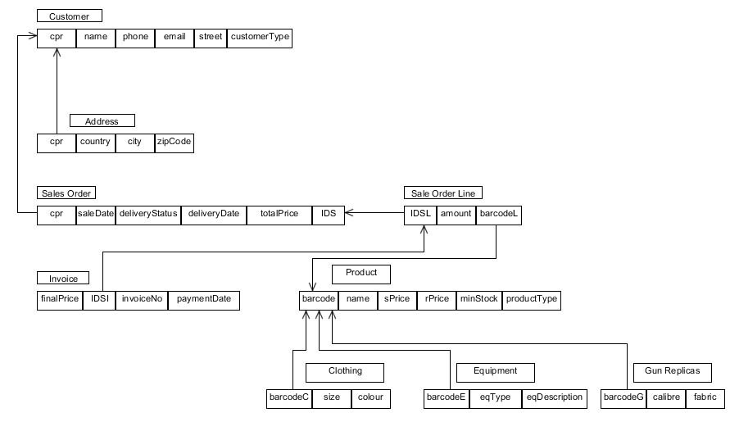

## Fully dressed use-case for order processing

|  |  |  |
| --- | --- | --- |
| Register order | | |
| Actors | Employee/Manager | |
| Pre-conditions | The desired product is available in stock | |
| Post-condition | The order is created and the products are added to the invoice | |
| Frequency | 10 times a day | |
| Main success scenario | Actors(Action) | System(Response) |
| 1.Employee searches for the desired product | 2.System shows if the product(s) are available |
| 3.Employee adds the products from the database | 4.System creates a new order |
| 5.Employee enters customer’s ID and type | 6.System calculates the price and makes a discount (if the requirements are fulfilled) |
|  | 7.System updates the stock and prints the receipt |
| Alternative flows | *-Item is not available in the stock | |

## Interaction diagrams, fully dressed use-case

